COMP8347
Internet Applications / Distributed Systems

Week 4 Class Activity (28.05)
Challenge: Fixing the Guestbook App

Individual Assignment — Report

1. Problem Overview
a) What was wrong in the provided Guestbook app
The starter project was a Django app (guestbook) that was intentionally broken in nine places. None of the four required features worked end to end. The defects were:
# | Location | Defect
1 | forms.py | Meta.fields only had 'message', so display_name was never rendered or saved.
2 | forms.py | clean_message() returned the raw value, allowing empty / whitespace-only messages.
3 | views.py (add_entry) | Session counter was re-assigned to its current value instead of incremented.
4 | views.py (add_entry) | Cookie pre-fill set initial for a display_name field the form did not have.
5 | views.py (set_name_cookie) | Cookie written as 'display_name' but read as 'displayname' (key mismatch).
6 | views.py (clear_name_cookie) | Deleted a non-existent key 'display_namex', leaving the real cookie.
7 | entry_list.html | 'Set my name cookie' link sent no name parameter, so the value was blank.
8 | add_entry.html | POST form missing CSRF token, so submissions failed with HTTP 403.
9 | add_entry.html | Template rendered form.display_name, a field the form did not define.
b) The required user features (in my own words)
- Add an entry — a visitor types a display name and a message and submits them.
- List entries — all messages are shown, each with its author and the time it was posted.
- Remember the name — a cookie stores the visitor's name so the form is pre-filled next time.
- Count this session's entries — the page shows how many entries the visitor added this session.
2. Implementation Summary (After Fix)
A. Add name + message
UI description. The 'Sign the Guestbook' page (/guestbook/add/) has a single-line Display name input and a multi-line Message textarea, plus a Save button. Each field shows a placeholder stating its maximum length (40 and 280 characters). The HTML maxlength attribute was deliberately removed so the user can type past the limit and the server-side validator can reject the input with a clear message.
What happens on submit. The form POSTs to add_entry. The view builds an EntryForm from request.POST; if it is valid it saves the Entry, increments the session counter, sets the name cookie, and redirects to the list (Post/Redirect/Get). If invalid, it re-renders the page with inline error messages.
Validation and error handling:
- Empty name/message — clean_message() strips whitespace and rejects empty input; the textarea is also required, so an empty message is never saved.
- Overly long inputs — limits are 40 characters for the name and 280 for the message (matching the model). Longer input is rejected server-side.
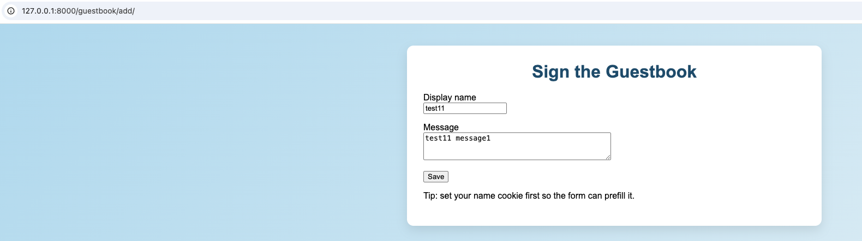
A1 — Add-entry form filled in (Display name + Message).
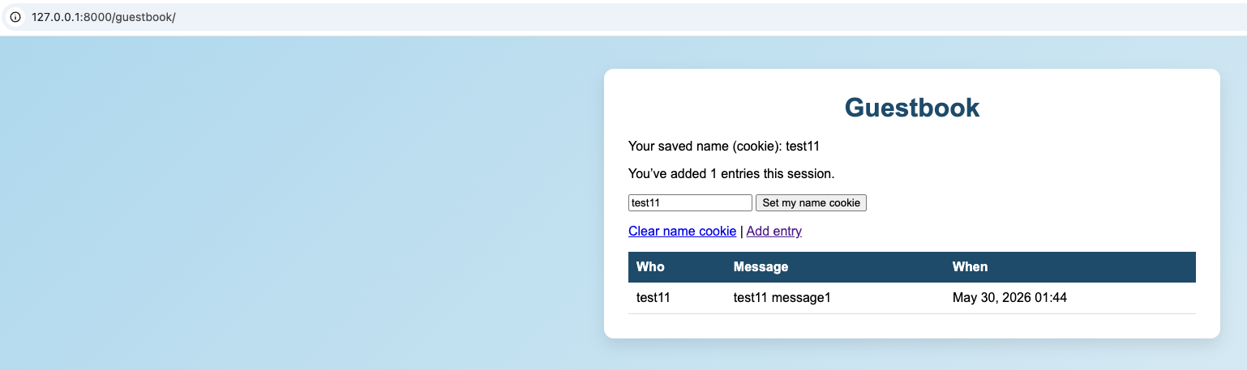
A2 — Entry added successfully; session counter shows 1.
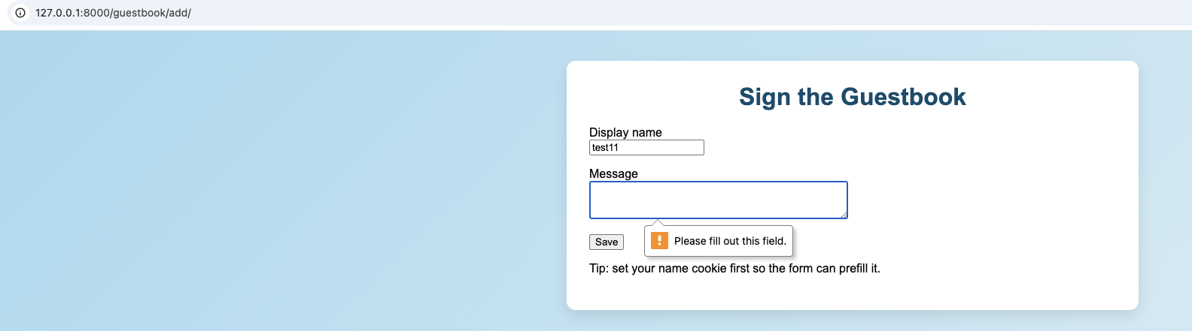
A3 — Empty message is blocked on submit.
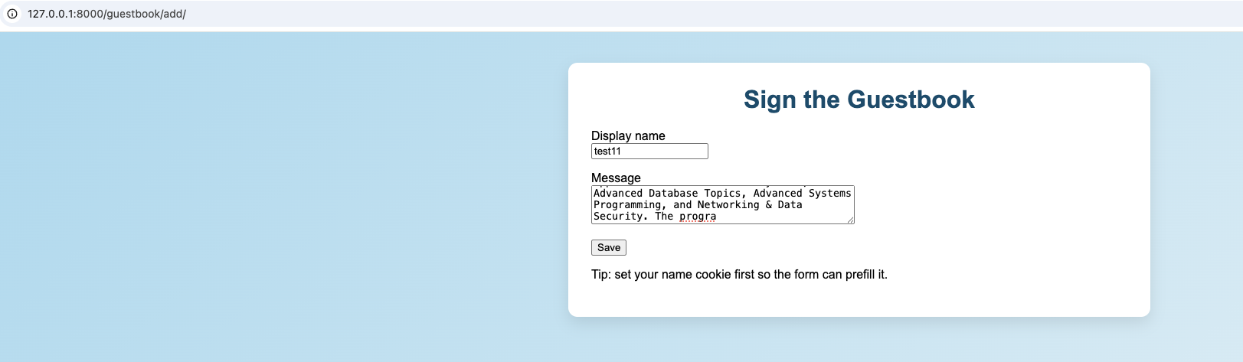
A4 — Over-long message input.
B. List messages with time + author
Data model (guestbook/models.py, class Entry):
Field | Type | Notes
display_name | CharField(max_length=40, blank=True, default="") | author; 'Anonymous' if blank
message | TextField(max_length=280) | the message body
created_at | DateTimeField(auto_now_add=True) | timestamp set on creation
- Storage — entries are kept in the starter app's SQLite database (db.sqlite3) via the Django ORM.
- Sorting order — newest first (order_by('-created_at')); a guestbook should surface the latest activity at the top.
- Time formatting — Django filter date:"M d, Y H:i", e.g. May 30, 2026 01:46. TIME_ZONE='UTC' and USE_TZ=True, so times are in UTC.
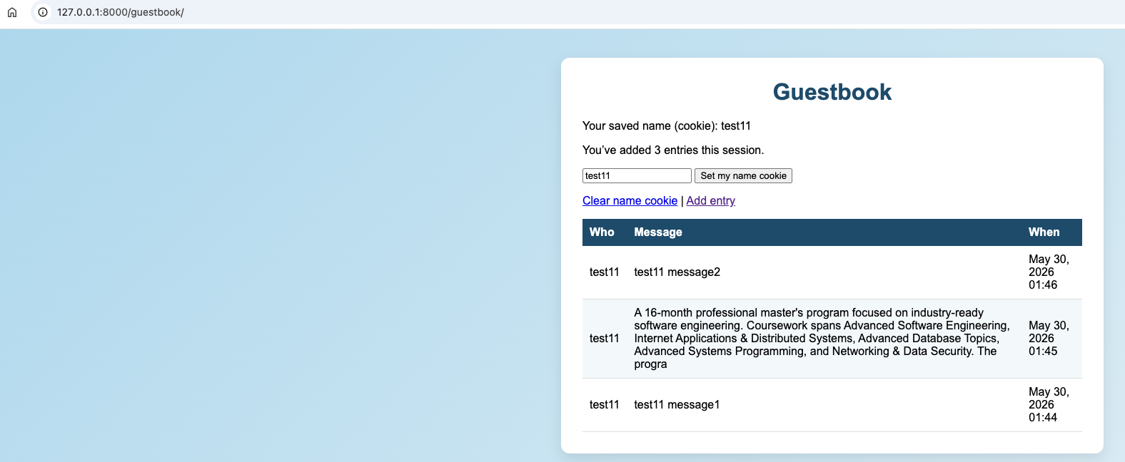
B1 — Multiple messages listed with author and time, newest first.
C. Cookie to remember the user's name
- Cookie name / value — 'displayname', storing the visitor's display name as a string.
- When set/updated — on every successful submission (using the posted name), and via the 'Set my name cookie' form on the list page.
- Expiry policy — persistent cookie, max_age = 7 days. Persistent (not session) because the goal is to remember the visitor across visits.
- How the UI uses it — on GET, the view passes the cookie as the form's initial value so the Display name field is auto-filled; the list page also shows the saved name.
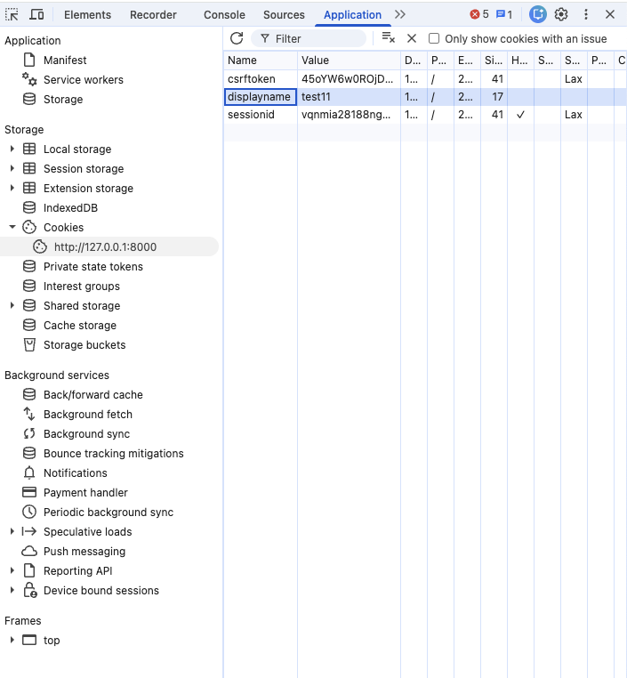
C1 — DevTools showing the 'displayname' cookie set after the first submit.
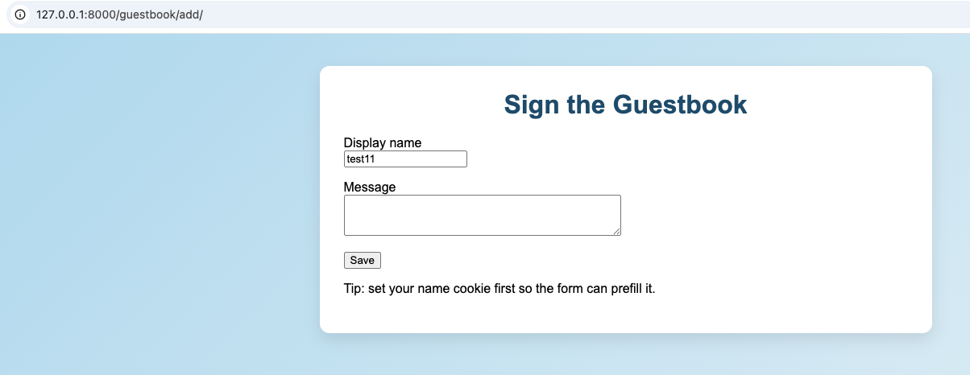
C2 — Add form auto-filled with the remembered name.
D. Track how many entries added this session
- Definition of 'session' — a server-side session (Django session framework, keyed by the sessionid cookie).
- Where the counter is stored — the server session dictionary: request.session['gb_added'].
- When it increments — only on a successful POST, after is_valid() and save(): session['gb_added'] = get('gb_added', 0) + 1.
- Refresh — preserved (same session cookie).
- New tab (same browser) — continues (same session cookie sent).
- New browser / incognito — a fresh session, so the counter restarts at 0.
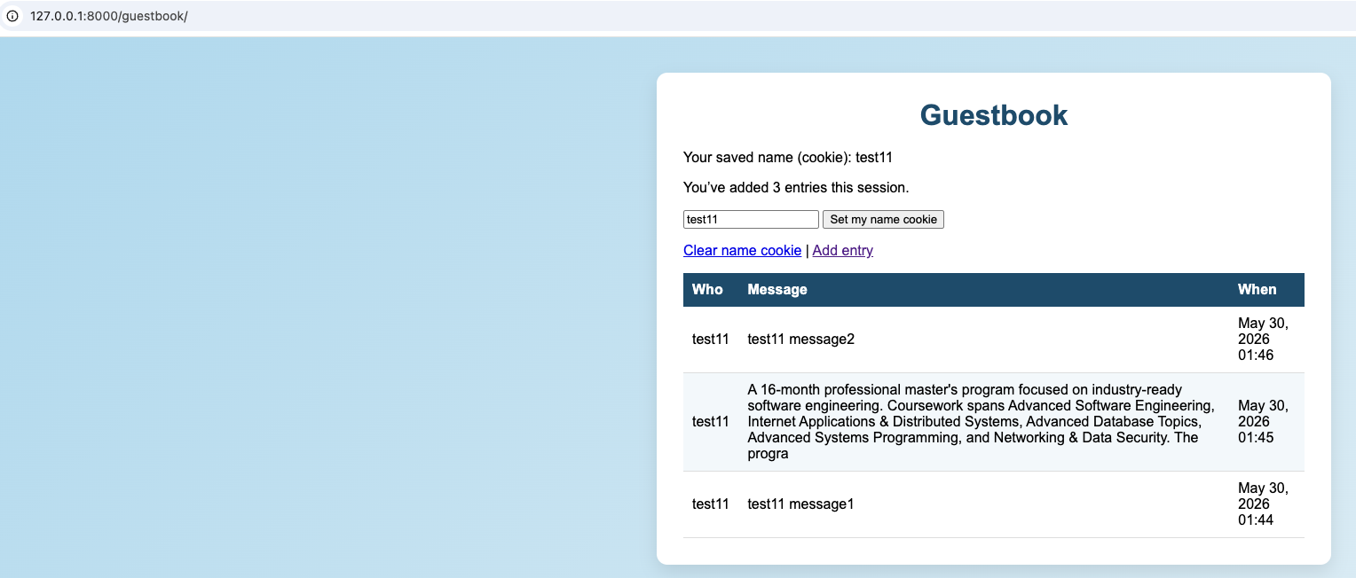
D1 — Session entry counter.
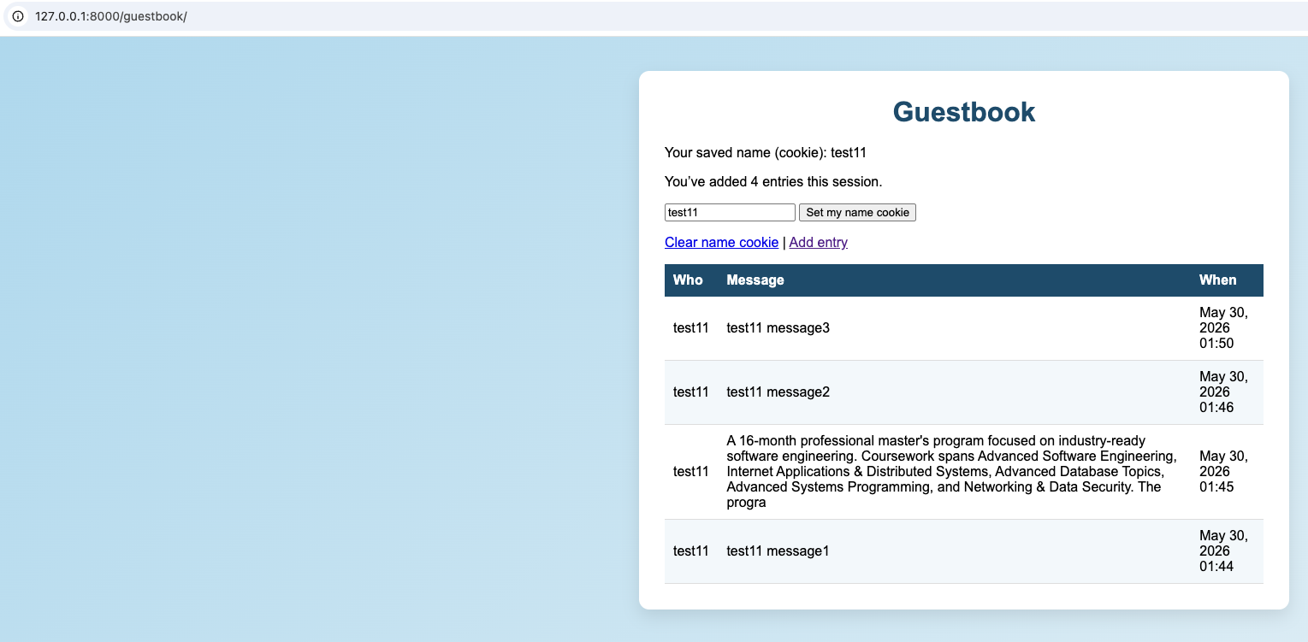
D2 — Counter increases as more entries are added.
3. Verification
An automated test suite (guestbook/tests.py, 5 tests) confirms the behaviour: adding an entry redirects, increments the counter and sets the name cookie; the list shows author + message, newest first; the add form pre-fills the name from the cookie; and empty or over-long messages are rejected and not saved. All 5 tests pass with: python manage.py test guestbook.

